Data mgmt and database design sec-05 Birwa Mukeshkumar Galia

**DATABASE PROJECT**

**TITLE: - INVENTORY MANAGEMENT SYSTEM**

Problem Statement:

The inventory system is needed in order to maintain the record of the stock that is available. There should be a system which maintains database consisting of number of products ordered by the supplier, the price of that product, the availability of that product as and when the supplier demands the product from the manufacturer and to keep the report of no. of the product that supplier order as well as the total expense (profit) that has been done by the manufacturer in particular month or in a year.

This database will use trigger as well procedure. For example, whenever supplier orders from manufacturer, there should be procedure which decrements that particular product quantity from total quantity and trigger must be called whenever that particular order is not available in manufacturer inventory.

ER Diagram (Rough):

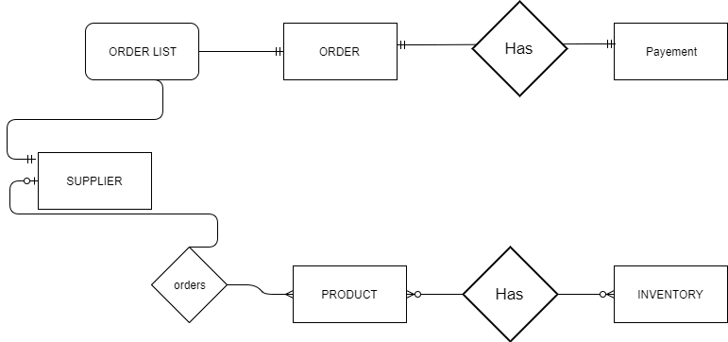

ER Diagram :

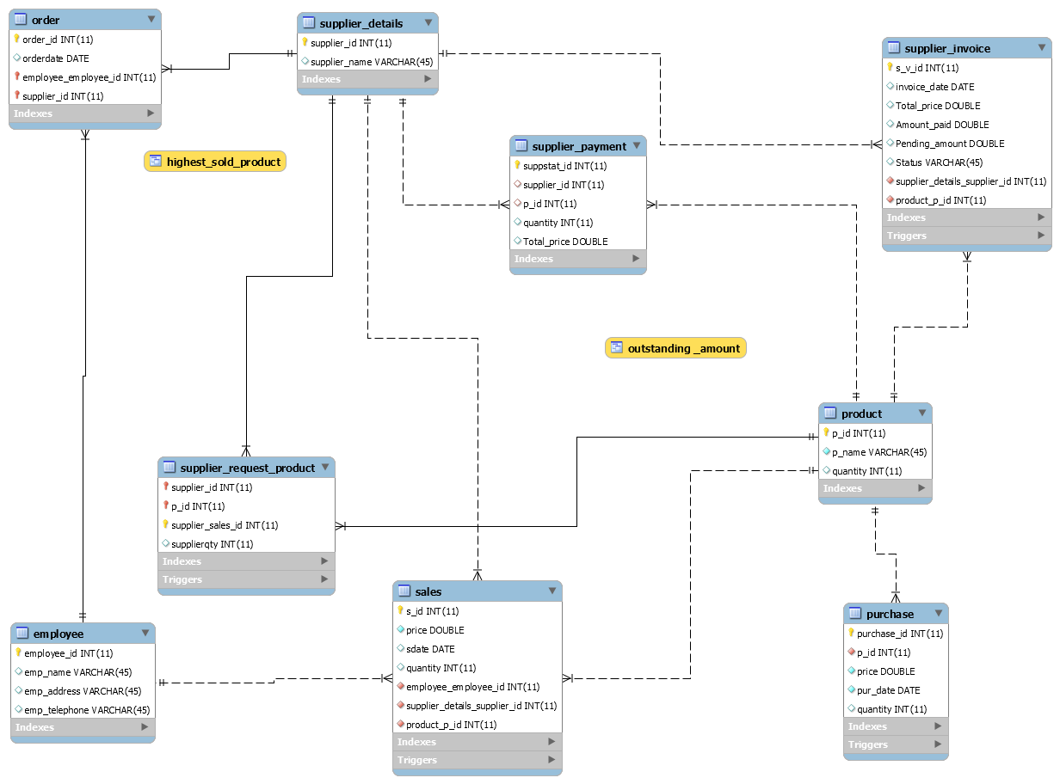

Functions:

1. To calculate the profit

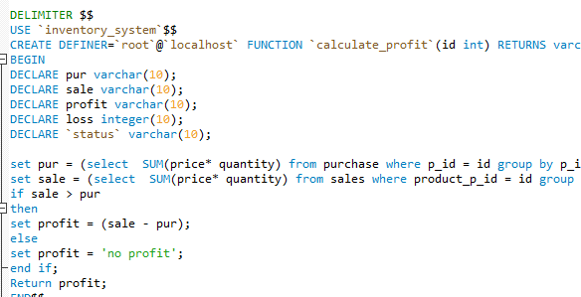

1. To calculate the loss

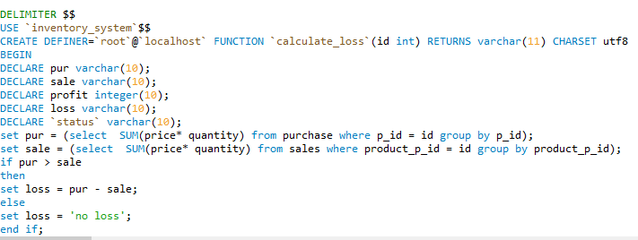

1. Total amount of the products purchased by the supplier

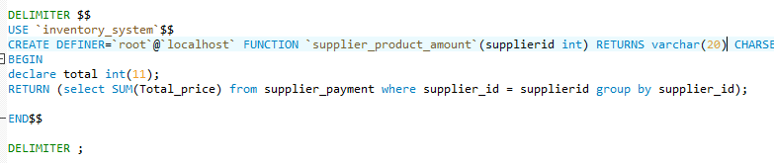

Views:

1. To view product sold the most

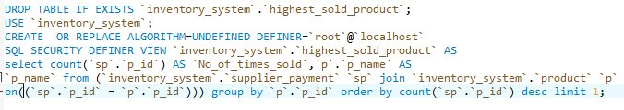

1. To view the outstanding amount of the suppliers

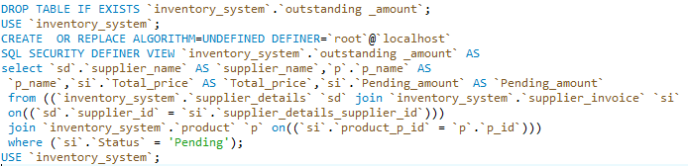

Stored Procedures:

1. To update the pending amount by mentioning the id and price

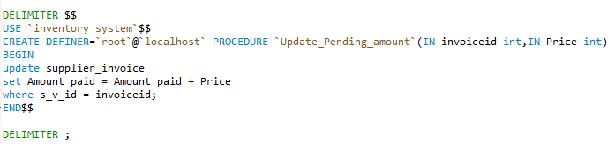

1. To view the products by the supplier

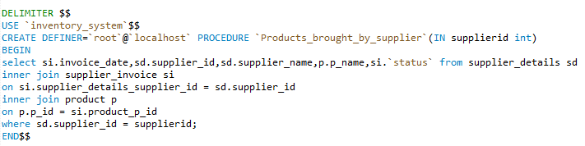

Triggers:

1. To update the quantity after purchase and sales of product

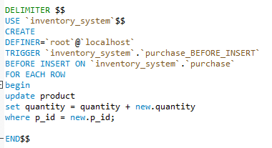

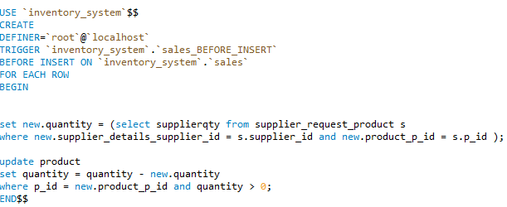

1. To update the supplier_invoice according to amount paid and whenever stored procedure (update_pending_amount) is executed

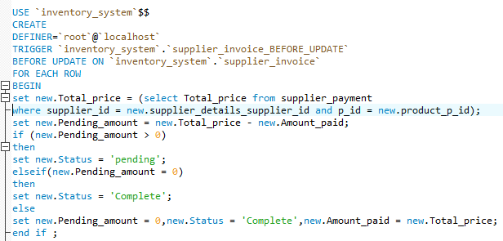

Graphs:

1. Total No. of Products available

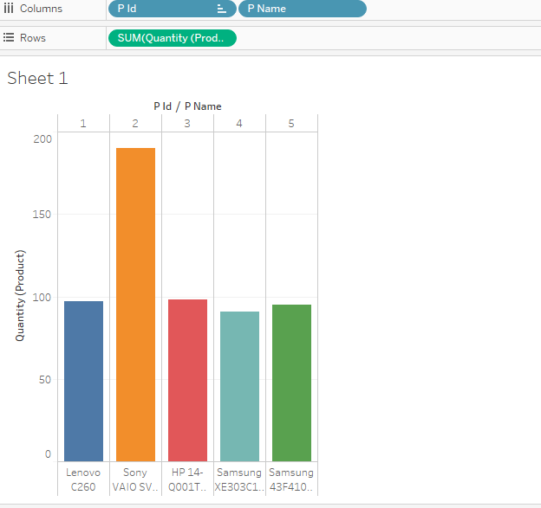

1. Purchase price and sales price of each product

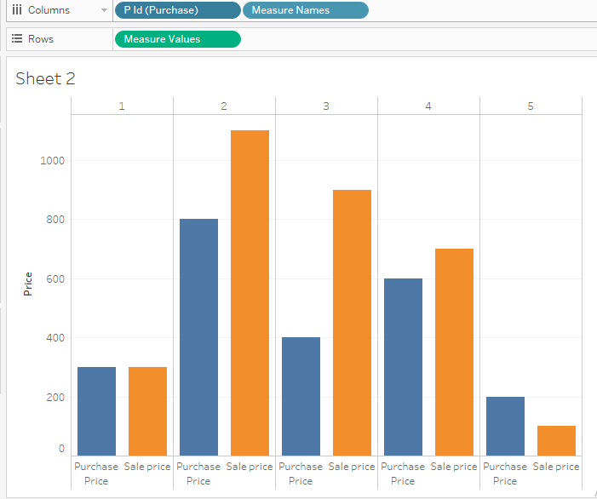

1. Calculating profit and loss of the product according to purchase price and sales price

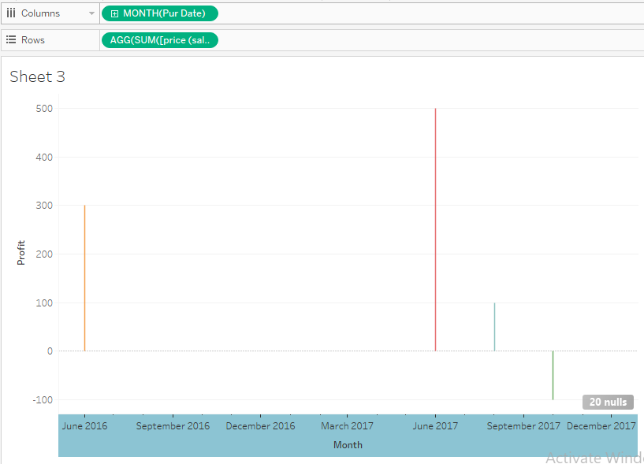

1. Supplier Billing Status

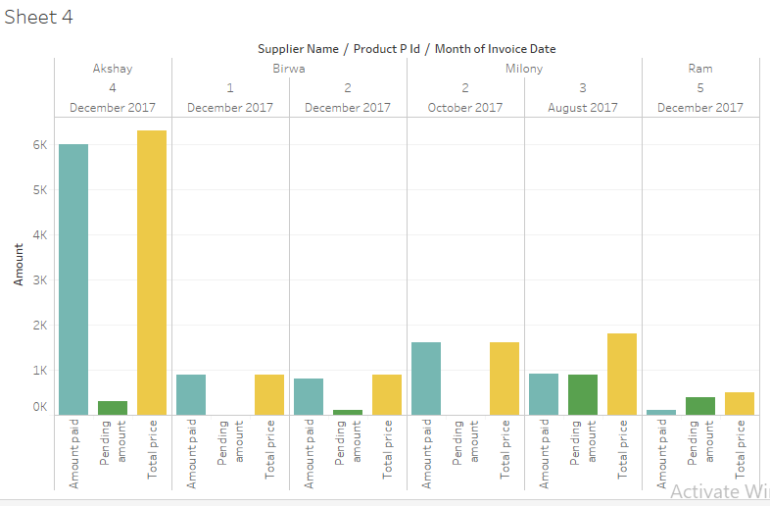

1. The employee having maximum products

